Twelfth Sunday in Ordinary Time
Reading I: Job 38:1, 8-11  Responsorial Psalm: 107:23-24, 25-26, 28-29, 30-31  Reading II: 2 Corinthians 5:14-17  Gospel: Mark 4:35-41  Readings may be found on the US Bishop’s website:  https://bible.usccb.org/bible/readings/062021.cfm#main-content  The selection from the Book of Job comes near the end of the book when God is asking Job questions. Job had demanded that God explain why good people suffered. God responded with a series of questions to Job. Job could not answer God’s questions and said that he would not question God’s ways again. | 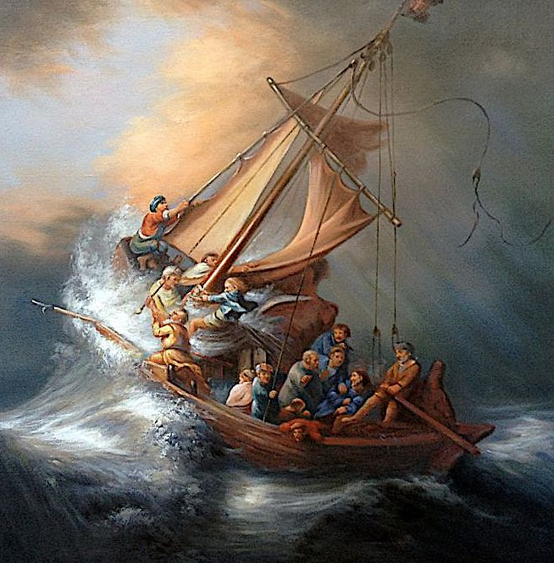  Rembrandt, 1633  Christ in the Storm on the Lake of Galilee
The verses that we have today highlight God's power over creation. God is the one who set the limits of the sea and brought order to creation. God is transcendent, that is, above all the limitations of creation. In contrast, humans cannot control storms, floods, or the sea. Humans need to recognize that the work of God is on a much higher level than what people can do.

The Gospel passage shows Jesus as stilling the storm and having authority over the powers of nature. This leads to the question, "Who this is this whom even wind and the sea obey?" The connection is being made with the first reading. God is the one who controls the storms and the seas. Jesus shows that he has authority over the storm and the sea. Jesus, who is human like us, is also like God. Jesus rebukes the wind. This parallels Jesus rebuking the unclean spirit at Capernaum and God rebuking the sea at the Exodus. (“He roared at the Red Sea, and it dried up. He led them through the deep as through a desert.” Ps 106: 9.) The power of Jesus shows forth the same power of the creator. Jesus is doing the work of God, and in the coming chapters, the disciples will recognize him as being one with God. At this point, they are in awe and still do not recognize who Jesus is.

The application for us is the storms in our lives. Most do not encounter storms on the sea. We do encounter small and large storms throughout life. It can be the loss of a job, the death of a loved one, or a medical diagnosis. In any of these, it is easy to cry out: "Teacher, do you not care that we are perishing?" The focus quickly becomes the strength of the problem, one's weakness, or one's lack of resources.

Mark presented this event not only to recall a historical moment but also to remind the Christians of his time that Jesus was with the disciples at that moment and that Jesus is with us at every moment. No matter what situation comes into our life, Jesus is with us. This applies to the church at large when disputes and controversies arise, when civil society is divided and in conflict, or when people experience trauma and loss.

Being in difficult situations invites us to pray. Prayer is communication with God. It is both speaking and listening. St Ignatius describes prayer as one friend talking with another. In the conversation of friends, there is honesty and vulnerability. There is also listening. One person does not monopolize the conversation.

In the second reading, Paul has two focal points. One is the source of his motivation, and the other is how to understand Jesus. The overall context is that Paul is contrasting his ministry with that of other teachers, particularly false teachers. Paul is motivated by the love that Jesus has shown for each person by his death on the cross. Paul is not working for his recognition nor to establish a following. He is doing ministry because God first loved him. “The love of Christ impels us.” He is serving because of the Love that God has shown him in the life, death, and resurrection of Christ. Paul is living for Christ, serving him, and sharing Christ.
His second point is that he has come to know that the risen Christ is the Lord. In his earlier days as a Jewish believer, the Messiah was a man who did God's will and worked great signs. Paul has come to know the risen Lord, who was not just a human messiah and wonderworker. Paul has come to know Jesus as the one who introduces the new creation. Faith in the risen Jesus brings one into the new creation. Faith in Jesus is a transformational experience.

Themes:
Virtues of hope and trust Faith in times of hardship
Jesus as the Risen Lord Saints who have suffered for the Gospel
Reflection Questions:
What helps you be aware of God’s presence in your life?

Does anything in creation connect you to God?

Are there obstacles that block your awareness of God’s presence?

Who is Jesus for you?

In calming the storm, Jesus did more than the disciples asked. Have you experienced God doing more than you asked or imagined?

What are some of the qualities of your prayer? How much do you listen in prayer?

What are some of the key motivations for your life?

What does the love of Christ impel you to do?

Prayer Suggestions:
For the Church: that by God’s grace, we may live as new creations, no longer living for ourselves but for Christ
For a deepening of our faith: that God will draw us into a deeper friendship so that we may grow in our ability to rely upon God in every circumstance
For a calming of the storms in our lives: that God will sustain us through the challenges of each day, give us the courage to make decisions, and enduring hope when we cannot foresee tomorrow
For freedom from fear: that Jesus will lead us from fear and worry to the trust of discipleship through the words of scripture
For courage and trust: that the Holy Spirit will empower us to bear witness to the Gospel in the face of opposition and the grace to respond lovingly to those who speak against us

© Joseph Milner, 2024

